

**UNIVERSITI TEKNOLOGI MARA**

**KEDAH BRANCH**

**SCHOOL OF INFORMATION SCIENCE**

**COLLEGE OF COMPUTING, INFORMATICS AND MATHEMATICS**

DIPLOMA IN LIBRARY INFORMATICS

(CDIM144)

**PROGRAMMING FOR LIBRARIES**

**(IML 208)**

INDIVIDUAL PROJECT: CAKE BOOKING SHOP

***Prepared by:***

DINA BATRISYIA MOHD ZAIDI 2022865422

KIM1443E

***Prepared for:***

SIR AIRUL SHAZWAN BIN NORSHAHIMI

**Date of Submissions:**

**4 JANUARY 2023**

INDIVIDUAL PROJECT: CAKE BOOKING SHOP

*PREPARED BY:*

**DINA BATRISYIA MOHD ZAID**

**(2022865422)**

**KIM1443E**

**DIPLOMA IN LIBRARY INFORMATICS**

**(CDIM144)**

**SCHOOL OF INFORMATION SCIENCE**

**COLLEGE OF COMPUTING, INFORMATICS AND MATHEMATICS**

Date of Submission:

4 JANUARY 2023

# **ACKNOWLEDGMENTS**

Assalamualaikum, Warahmatullahi Wabarakatuh.

Salam UiTM Dihatiku.

First and foremost, I would like to express my sincere gratitude to Allah, the Almighty, for giving me the ability and well-being needed to fulfil my responsibilities. My IML 208 lecturer, Sir Airul Shazwan Bin Norshahimi, deserves a very special thank you for his inspirational support and guidance, which contributed greatly in my commitment to completing the assignment.

Without my parents and siblings, to whom we owe a great deal, I would not have been able to embark on this journey. Their support and love for my academic endeavors are what enable me to persevere in the face of adversity. Your prayers for me are what have kept me going this far without wanting to give up everything. Words can never express how I feel.

Last but not least, I want to thank me for believing in me, I want to thank me for doing all the hard work, I want to thank me for having no days off, I want to thank me for never quitting, I want to thank me for always being a giver and try to give more than I receive, I want to thank me for trying to do more right than wrong, I want to thank me for just being me at all times.

**Table of Contents**

**ACKNOWLEDGMENTS** i

**1.0** **INTRODUCTION** 1

**2.0** **FLOW CHART** 2

**3.0** **SNAPSHOOTS OF PROGRAM CODE (PY)** 3

**4.0 SNAPSHOOTS OF GUI** 6

**4.0** **SNAPSHOOTS OF DATABASE (SQL)** 7

# **INTRODUCTION**

In a world where convenience meets culinary delight, an innovative Cake Booking Shop becomes as a doorway to a digital confectionery haven. This innovative platform seamlessly combines an interactive interface with a flexible database, providing an integrated combination of choice and personalized service. Welcome to a delightful journey where selecting and capturing your favorite cakes becomes a graceful pleasure.

Step into this digital bakery and immerse yourself in a tempting array of cake options. From the luxurious "Royal Velvet Delight" to the enchanting "Midnight Bliss Cake," a variety of flavors awaits your discovery. The user-friendly interface, decorated with intuitive menus, invites you to indulge your senses and explore a world of confectionery wonders.

Furthermore, in recognition of your trustworthiness, the platform provides an exclusive membership with an array of interesting benefits. When you sign up for the membership card, you'll gain access to fantastic savings that are seamlessly integrated into your booking experience. During checkout, a simple selection reveals a sweet surprise—a symbolic of appreciation for your support.

Explore the ease and charm of cake selection, where technology meets taste, and explore the simplicity and elegance of cake selection intertwined with the allure of membership benefits. Experience the seamless blend of digital convenience and gourmet pleasure at your fingertips.

# **FLOW CHART**

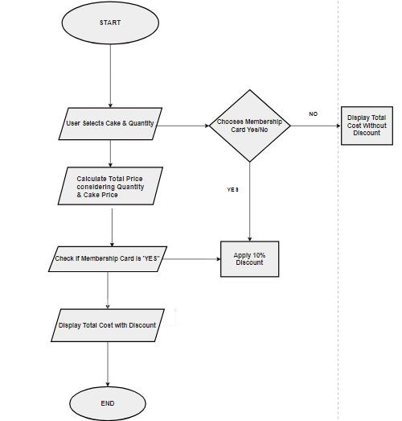

Table 1

# **SNAPSHOOTS OF PROGRAM CODE (PY)**

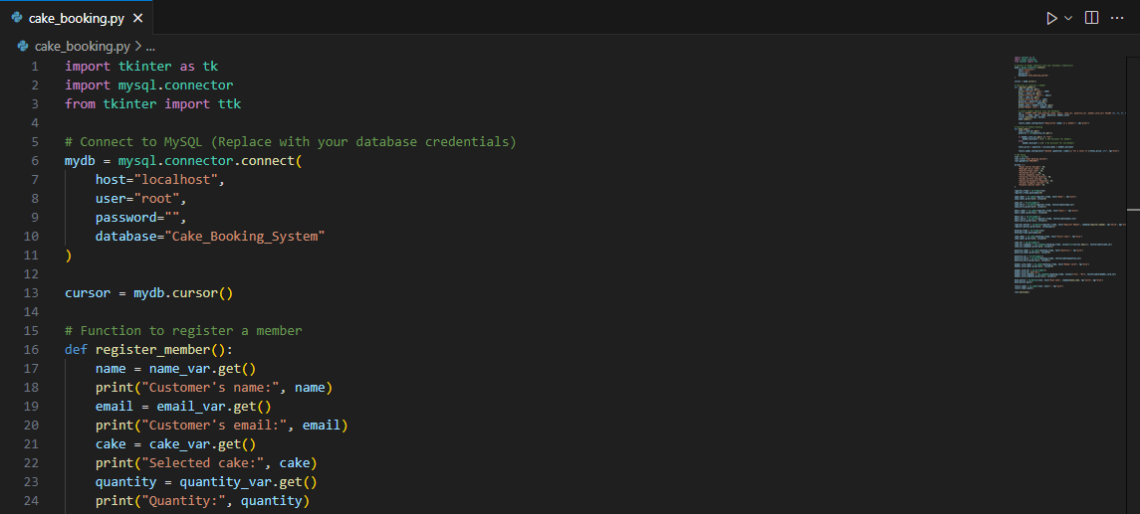

Table 2

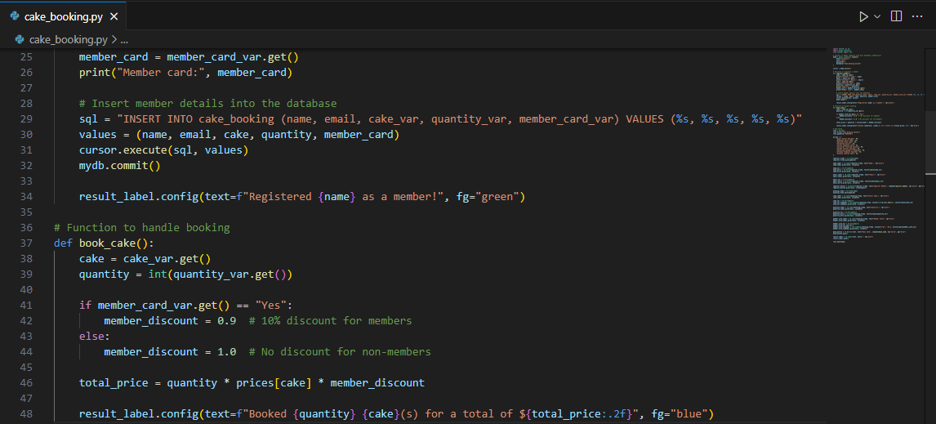

Table 3

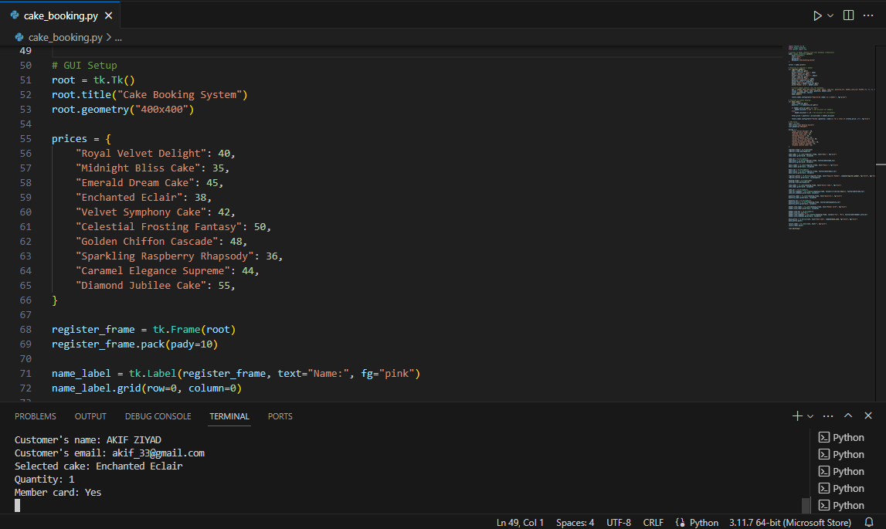

Table 4

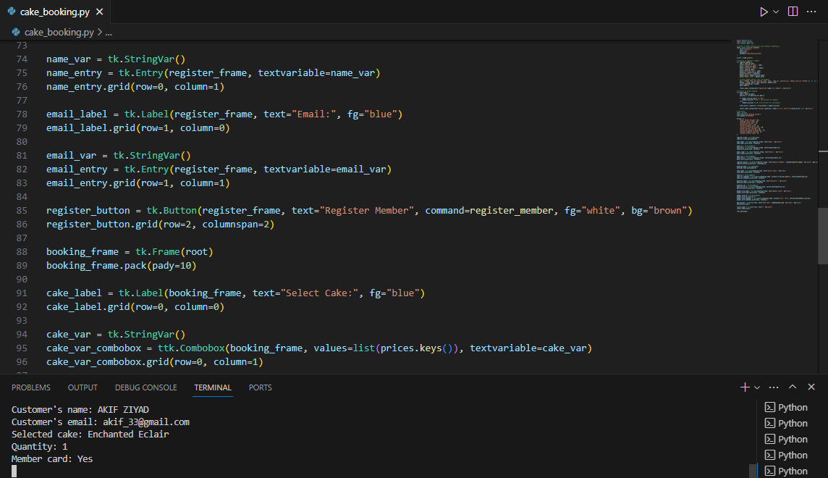

Table 5

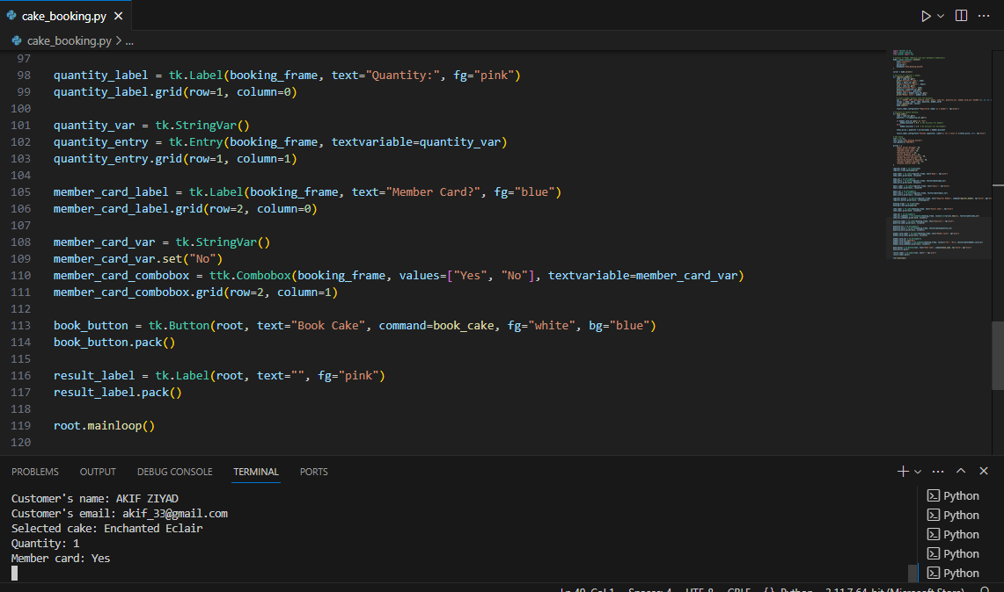

Table 6

# **4.0 SNAPSHOOTS OF GUI**

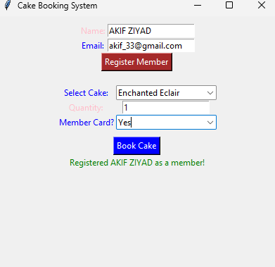

Table 7

# **SNAPSHOOTS OF DATABASE (SQL)**

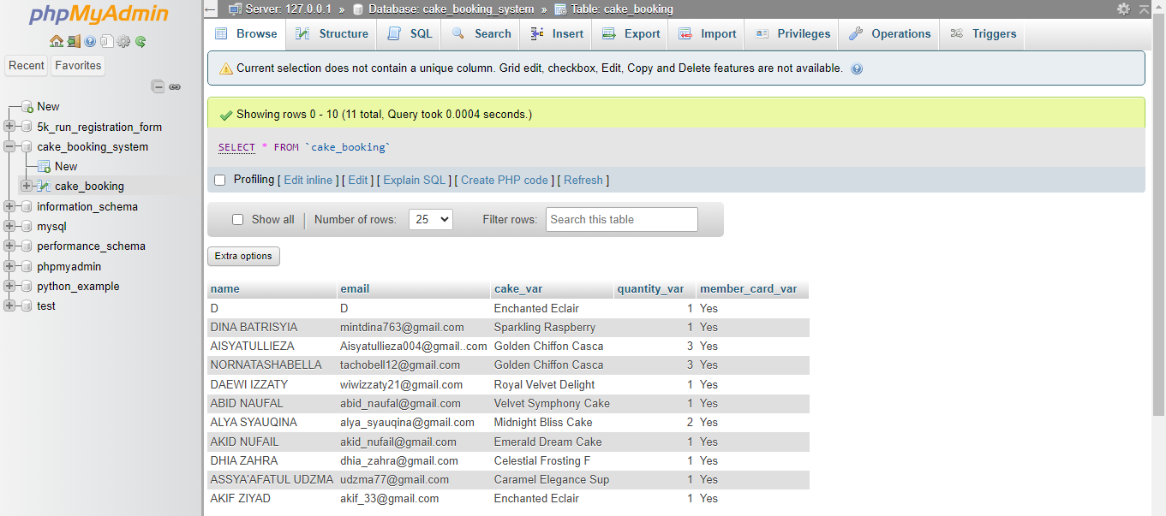

Table 8

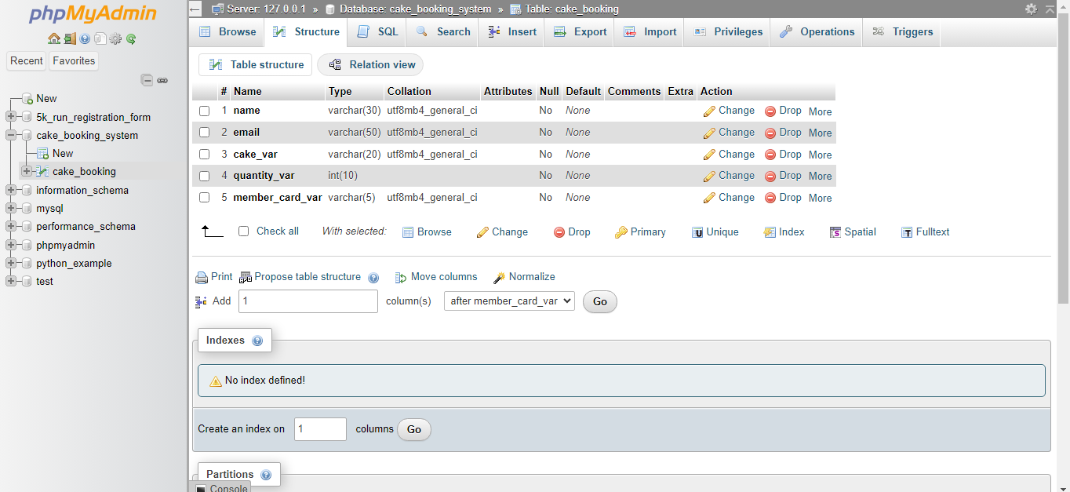

Table 9